
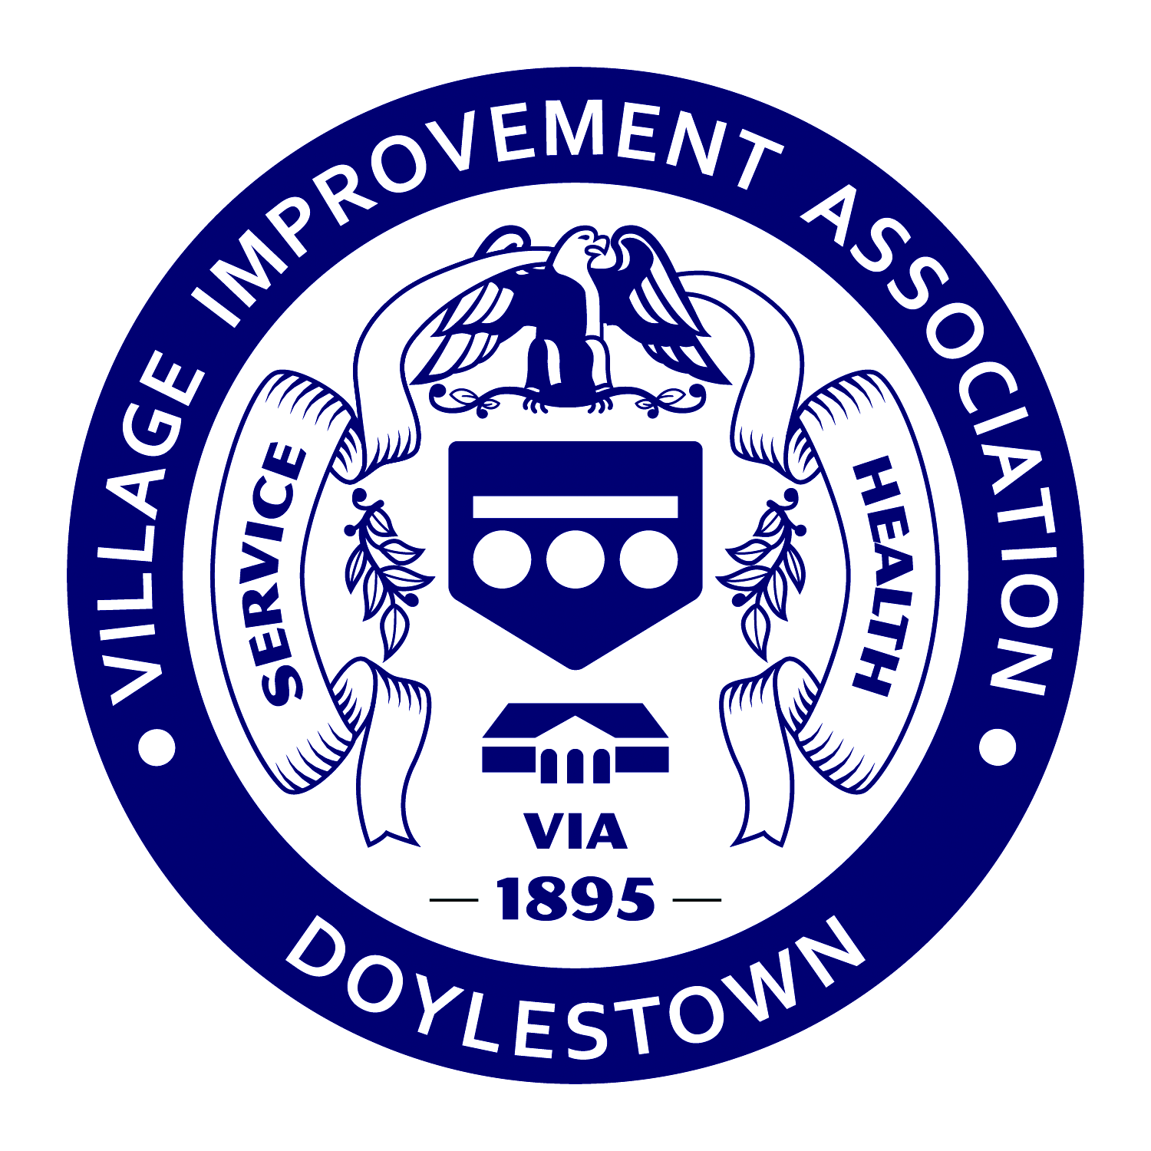

FOR IMMEDIATE RELEASE DATE: June 8, 2015
CONTACT: Beth Long PHONE: 215-345-2131
Communications/PR blong@dh.org

VIA Awards Scholarships to Local Teens
Community recognition also part of June 2nd program

WARRINGTON — The Village Improvement Association of Doylestown (VIA) presented four scholarships to graduating high school seniors at its annual June luncheon at the Warrington Country Club. The VIA, which is celebrating its 120th anniversary, also heard from two students who received scholarships to a recent Hugh O’Brian Youth Leadership (HOBY) program, and recognized two community members for their service to others.

The VIA Ruth Boland Memorial Nursing Scholarship, a $2,000 award, was presented to Emily Burton, a Central Bucks East High School honor student who participates in several school organizations, including Student Council, Key Club and Interact Club and is a founding member of the Patriot Paws animal rights group. Emily also volunteers at a local nursing home. She will attend Penn State University’s main campus in the fall to pursue a Bachelor’s degree in Nursing and plans to attend graduate school to become a nurse practitioner.

Three scholarships of $2,000 each in honor of sisters Hannah Pollock and Laura Haddock were awarded to graduating seniors Abby Rubin, Michele Karn and Pooja Gandhi.

Abby Rubin is a Central Bucks South High School honor student and National Merit Scholarship finalist. She is a member of the National French Honor Society, Environmental Club, Musical Set Design group and president of the Interact Club. Abby works with a special needs student teaching him Hebrew in order to prepare for his Bar Mitzvah. She will attend Washington University in St. Louis to begin a 5-year program to earn a master’s degree in Occupational Therapy before pursuing a doctoral degree.

Michelle Karn is a CB South senior who plays the flute and violin in band and orchestra. She is a member of the National Honor Society, the Spanish Honor Society, Key Club, High School Youth Group, Christian Fellowship Club and Mill Creek Mentors. In 2014 she received the Union League Good Citizenship Award. Michelle will study Biology and Pre-Medicine at Franciscan University of Steubenville in Ohio with the intention of continuing on to medical school to become a pediatrician.

Pooja Gandhi is a CB East senior who serves as treasurer of the Student Council, is a member of the National Honor Society and runs track. She also participates in the Central Bucks Community Band. Pooja has given more than 400 hours of volunteer service to Doylestown Hospital. She will attend La Salle University to obtain a Bachelor’s of Science degree in Communication Sciences and Disorders and a Clinical Competence Certificate in Speech-language Pathology.

Each year, the VIA awards two scholarships to a HOBY program for youth leadership and service learning. The HOBY winner from Central Bucks West is Emily Nelson. The CB East winner is Alekhya Gunturi. The sophomores shared details of their recent experience in the HOBY program that took place at Villanova University.

In addition to awarding the scholarships, the VIA also recognized an individual and community organization for their work in the Central Bucks area. Ray Hendricks, aka the Blue Bird Man, has been installing bluebird houses in the area for years and is consulted as an ornithologist. Diane Smith, president of Roxy Reading Therapy Dogs, was honored for her organization’s commitment to providing animal therapy in schools, medical homes, the court system and most recently the Della Penna Pediatric Center of Doylestown Hospital. Smith brought the original Roxy along to receive the recognition.

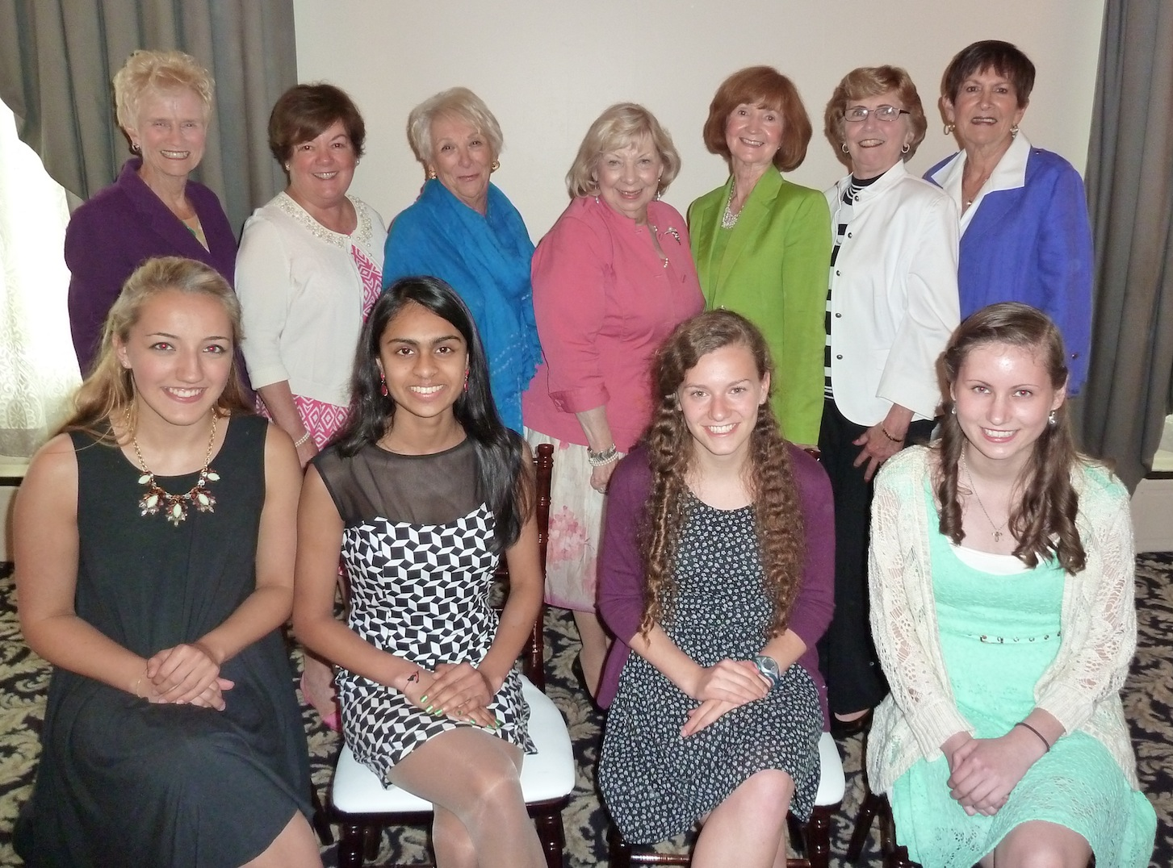
Photo (L-R)
Group Photo (Back Row): Joan Parlee, Maureen Casey, Karen O'Brien, Chairman, Mary Ellen Stanton; Vice-Chairman, Kathryn Lambert; Barbara Thompson and Grace Mattes Not pictured: Mary Lou Gehring
(Front Row): Emily Burton, Pooja Gandhi, Abby Rubin, Michele Karn and Education Committee vice-chairman Kathy Lambert
HOBY: Alekhya Gunturi, HOBY chairman Kathryn McKenna and Emily Nelson

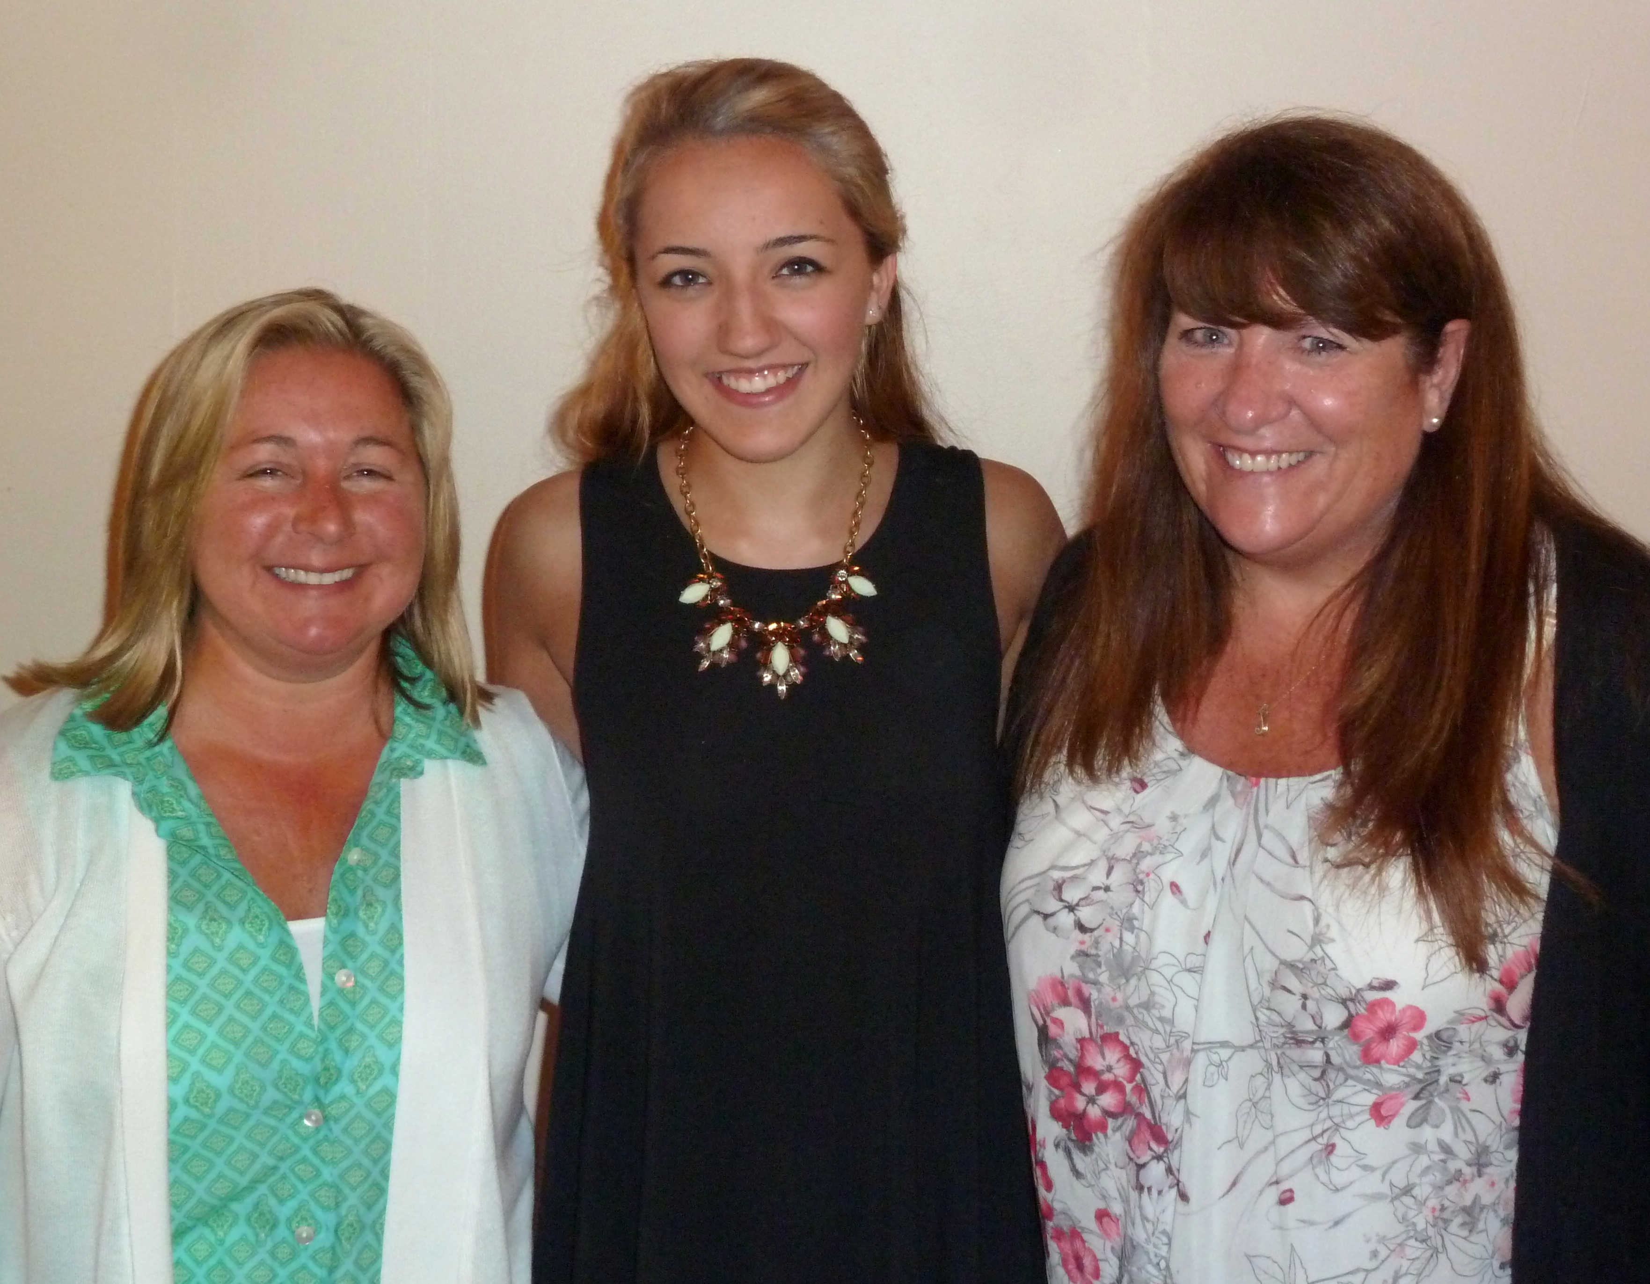

Boland: Kathleen Boland, Michelle Karn (recipient of the VIA Ruth Boland Nursing Scholarship) and Jean Boland
###
DH-093-2015

